Describe the classes inside the package by drawing a class diagram.

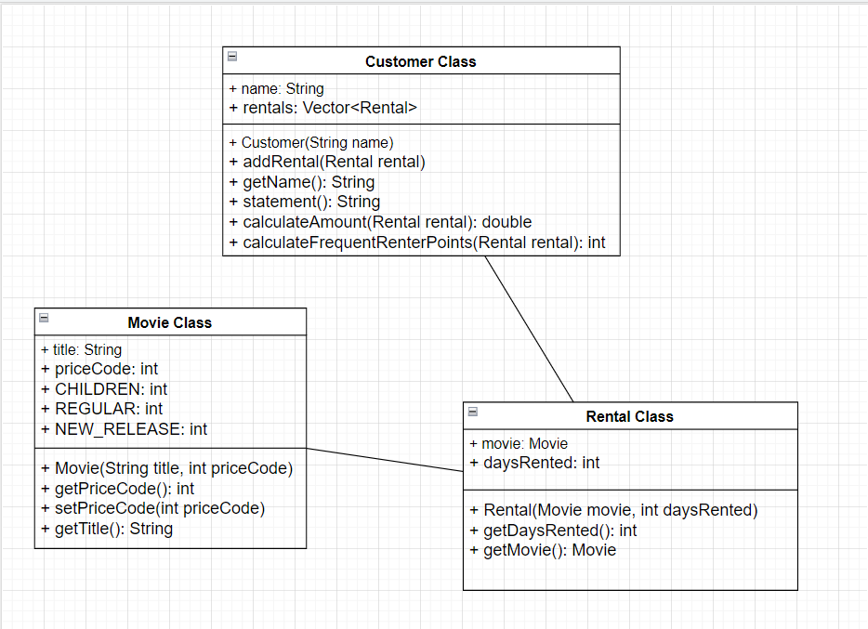

Write the main program to implement the following use cases:

A client has lend 3 movies :

”Rogue One” of type NEW RELESASE during 5 days ,

”Frozen” of type CHILDREN during 7 days,

”Star Wars III” of type REGULAR during 4 days.

Information about the client will be displayed on the standard output.

Describe interactions between objects at runtime:

* Main program creates movie instances: rogueOne, frozen, starWarsIII.
* Main program creates rental instances: rental1, rental2, rental3.
* Main program creates a customer instance: customer.
* Main program adds rentals to the customer: ‘customer.addRental(rental1)’, ‘customer.addRental(rental2)’, ‘customer.addRental(rental3)’. ‘customer.statement() ‘is called, invoking interactions with rentals and movies to calculate the total amount and frequent renter points.
* The result is displayed on the standard output.

Give a list of improvements required to satisfy criteria for the lisibility, the maintenability , the re-usability and the extensibility of your code:

1. Readability:

* Use meaningful variable and method names.
* Add comments to explain complex logic.

1. Maintainability:

* Separate concerns by creating separate classes for printing and calculation.
* Replace magic numbers with constants.

1. Reusability:

* Consider creating an interface for movie types to support future extensions.
* Encapsulate movie-related logic within the Movie class.

1. Extensibility:

* Introduce a MovieType interface for different movie types.
* Use constants or an enum for movie price codes.